Warning – Electronic Locking Differential (ELD) – CGEA1.3

Functional Description

The purpose of the ELD Warnings is to provide instruction to the driver for engaging the Electronic Locking Differential (ELD) and as well as provide status when ELD is engaged or disengaged. ELD is generally implemented on Pick Up Trucks only although this could be expanded.

The ELD Warning function correlates the RearDiffLckMsg_D_Rq signal, the Display_Units, the E-locker_Cfg and the operational mode to display the appropiate warning in the message center.

This version also includes SVT specific 40 MPH and 65 km/h warning messages required due to unique SVT requirements.

Interfaces

Interface Context Diagram (I/O Block Diagram)
Figure 1 Warning – ELD Context Diagram

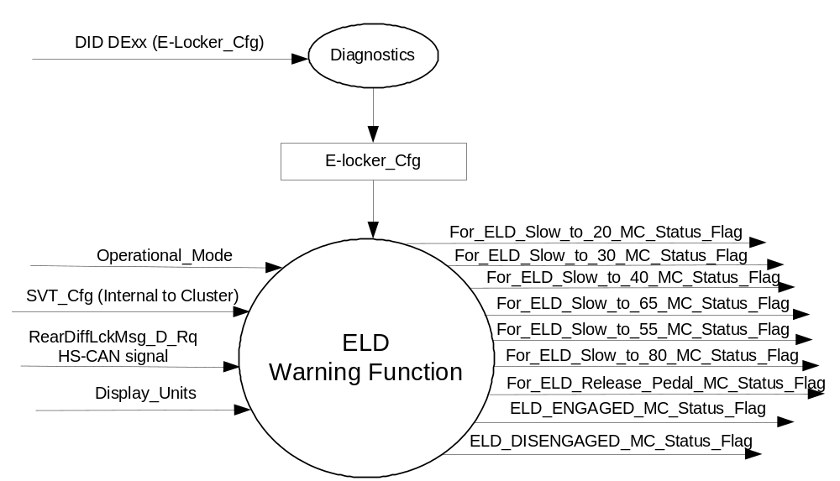

Inputs
      - INTERNAL:
- Operational_Mode
- English_metric_mode
- SVT_Cfg – Internal Supplier Config bit that differentiates the SVT cluster from other cluster variants.

- MUX message from the HS_CAN bus

- RearDiffLckMsg_D_Rq Signal
Signal Name | ID | Size  (bits) | Pos  (bit) | Detail | Units | Res | Offset | State Encoded | Min. | Max.
RearDiffLckMsg_D_Rq | 0x4A2 | 3 | 19 |  | SED | 1 | 0 |  | 0 (0x0) | 7  (0x7)
 |  |  |  | Normal__No  _Message |  |  |  | 0x0
 |  |  |  | Locker_2High_Speed |  |  |  | 0x1
 |  |  |  | Locker_4Auto_Speed |  |  |  | 0x2
 |  |  |  | Locker_4High_Speed |  |  |  | 0x3
 |  |  |  | Locker_4Low_Speed |  |  |  | 0x4
 |  |  |  | Locker_Accel_Pedal |  |  |  | 0x5
 |  |  |  | Locker_Enabled |  |  |  | 0x6
 |  |  |  | Locker_Disabled |  |  |  | 0x7

Outputs
- For_ELD_Slow_to_20_MC_Status_Flag that is used to control the Warning displayed in the message center.
- For_ELD_Slow_to_30_MC_Status_Flag that is used to control the Warning displayed in the message center.
- For_ELD_Slow_to_40_MC_Status_Flag that is used to control the Warning displayed in the message center.
- For_ELD_Slow_to_65_MC_Status_Flag that is used to control the Warning displayed in the message center.
- For_ELD_Slow_to_55_MC_Status_Flag that is used to control the Warning displayed in the message center.
- For_ELD_Slow_to_80_MC_Status_Flag that is used to control the Warning displayed in the message center.
- For_ELD_Release_Pedal_MC_Status_Flag that is used to control the Warning displayed in the message center.
- ELD_ENGAGED_MC_Status_Flag that is used to control the Warning displayed in the message center.
- ELD_DISENGAGED_MC_Status_Flag that is used to control the Warning displayed in the message center.

Function/Performance

Operational Modes

Mode | Differentiating Vehicle Conditions
Sleep Mode | OFF
Limited Mode | OFF
Normal Mode | ELD Warnings OFF/ON
Crank Mode | OFF

Voltage Levels

Refer to the Cluster Features Table located in the Operational Modes and Voltage Range Strategies Section of this SPSS

Human-Machine Interface

Visual

Indicator Graphics / Display Format
Message Center Text Warning Message as defined in section 1.3.5.7 of this document.

1.3.3.1.2 Indicator Color Coordinates

Reference section COLOR & ILLUMINATION REQUIREMENTS (GRAPHICS).

Audio

No Message Center Warning Chime is associated with this Warning.

Switch Control Logic

None.

System Accuracy

Within 100 msec of receiving a message that results in a change of state the cluster will update the output flag to the proper state.

Operation: Performance and Functional

Subsystem Algorithm Flowchart / State Diagram

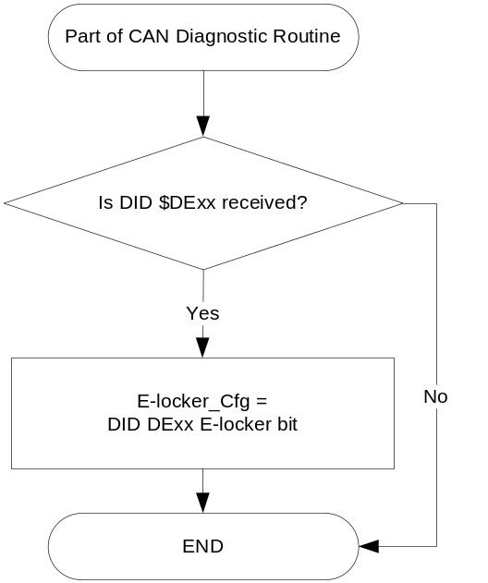
- State Matrix for ELD Warnings

Operational _Mode | E-locker_ Cfg | SVT_Cfg | RearDiffLckMsg _D_Rq | Display_ Units | ELD_ENGAGED_MC_Status_Flag | ELD_DISENGAGED_MC_Status_Flag | For_ELD_ Slow_to_ 20_ MC_Status_ Flag | For_ELD_ Slow_to_ 30_ MC_Status_ Flag | For_ELD_ Slow_to_ 40_ MC_Status_ Flag | For_ELD_ Slow_to_ 65_ MC_Status_ Flag | For_ELD_ Slow_to_ 5_ MC_Status_ Flag | For_ELD_ Slow_to_ 80_ MC_Status_ Flag | For_ELD_ Release_ Pedal_ MC_Status_ Flag
Normal | Enabled (0x1) | X | Locker_ 2High_ Speed (0x1) | E | Inactive | Inactive | Active | Inactive | Inactive | Inactive | Inactive | Inactive | Inactive
Normal | Enabled (0x1) | X | Locker_ 2High_ Speed (0x1) | M | Inactive | Inactive | Inactive | Active | Inactive | Inactive | Inactive | Inactive | Inactive
Normal | Enabled (0x1) | Disabled | Locker_ 4Auto_ Speed (0x2) | E | Inactive | Inactive | Active | Inactive | Inactive | Inactive | Inactive | Inactive | Inactive
Normal | Enabled (0x1) | Disabled | Locker_ 4Auto_ Speed  (0x2) | M | Inactive | Inactive | Inactive | Active | Inactive | Inactive | Inactive | Inactive | Inactive
Normal | Enabled (0x1) | Enabled | Locker_ 4Auto_ Speed (0x2) | E | Inactive | Inactive | Inactive | Inacitve | Active | Inactive | Inactive | Inactive | Inactive
Normal | Enabled (0x1) | Enabled | Locker_ 4Auto_ Speed  (0x2) | M | Inactive | Inactive | Inactive | Inactive | Inactive | Active | Inactive | Inactive | Inactive
Normal | Enabled (0x1) | X | Locker_ 4High_ Speed  (0x3) | E | Inactive | Inactive | Active | Inactive | Inactive | Inactive | Inactive | Inactive | Inactive
Normal | Enabled (0x1) | X | Locker_ 4High_ Speed  (0x3) | M | Inactive | Inactive | Inactive | Active | Inactive | Inactive | Inactive | Inactive | Inactive
Normal | Enabled (0x1) |  | Locker_ 4Low_ Speed  (0x4) | E | Inactive | Inactive | Inactive | Inactive | Inactive | Inactive | Active | Inactive | Inactive
Normal | Enabled (0x1) | X | Locker_ 4Low_ Speed  (0x4) | M | Inactive | Inactive | Inactive | Inactive | Inactive | Inactive | Inactive | Active | Inactive
Normal | Enabled (0x1) | X | Locker_ Accel_Pedal  (0x5) | X | Inactive | Inactive | Inactive | Inactive | Inactive | Inactive | Inactive | Inactive | Active
Normal | Enabled (0x1) | X | Locker_Enabled (0x6) | X | Active | Inactive | Inactive | Inactive | Inactive | Inactive | Inactive | Inactive | Inactive
Normal | Enabled (0x1) | X | Locker_Disabled (0x7) | X | Inactive | Active | Inactive | Inactive | Inactive | Inactive | Inactive | Inactive | Inactive
Normal | Enabled (0x1) | X | 0x0, Missing or never received | X | Inactive | Inactive | Inactive | Inactive | Inactive | Inactive | Inactive | Inactive | Inactive
All Other Cases |  |  |  |  | Inactive
X=Don’t Care

- ELD Warning MC Status Flags to MC Warning Message ID

Description of Warning | MC_Status_Flag | Message center Warning ID
Driver attempts to engage locker at high speed in 4x2 mode or 4x4 High mode and mode = english | For_ELD_ Slow_to_20_ MC_Status_Flag | W1003
Driver attempts to engage locker at high speed in 4x2 mode or 4x4 High mode and mode = metric | For_ELD_ Slow_to_30_ MC_Status_Flag | W1004
Driver attempts to engage locker at high speed in 4x2 mode or 4x4 High mode and mode = English  SVT Only | For_ELD_ Slow_to_40_ MC_Status_Flag | W3525
Driver attempts to engage locker at high speed in 4x2 mode or 4x4 High mode and mode = metric  SVT Only | For_ELD_ Slow_to_65_ MC_Status_Flag | W3526
Driver attempts to engage locker at high speed in 4x4 Low mode and mode = english | For_ELD_ Slow_to_55_ MC_Status_Flag | W1005
Driver attempts to engage locker at high speed in 4x4 Low mode and mode = metric | For_ELD_ Slow_to_80_ MC_Status_Flag | W1006
Driver attempts to engage locker while accelerating | For_ELD_ Release_Pedal_ MC_Status_Flag | W1007
Locker has been engaged | ELD_ENGAGED_MC_Status_Flag | W1008
Locker has been disengaged | ELD_DISENGAGED_MC_Status_Flag | W1009

Operation Description (supports algorithm flowchart /state diagram)

- For definition of how the Message Center arbitrates and displays Active warnings, see the Warning / Alert Display Logic Diagram, located in the Message Center – X Display with W Button Interface section of this SPSS (where X and W are appropriate values in this document).

Function Safety Classification (EMC)

Class B

Memory Storage

Parameter Name | Description | Value at  Battery Connect | Value at  Module Wake-up
For_ELD_ Slow_to_20_ MC_Status_Flag | Used to control the state of the warning to the Message Center arbitrator | INACTIVE (0x0) | INACTIVE (0x0)
For_ELD_ Slow_to_30_ MC_Status_Flag | Used to control the state of the warning to the Message Center arbitrator | INACTIVE (0x0) | INACTIVE (0x0)
For_ELD_ Slow_to_40_ MC_Status_Flag | Used to control the state of the warning to the Message Center arbitrator | INACTIVE (0x0) | INACTIVE (0x0)
For_ELD_ Slow_to_65_ MC_Status_Flag | Used to control the state of the warning to the Message Center arbitrator | INACTIVE (0x0) | INACTIVE (0x0)
For_ELD_ Slow_to_55_ MC_Status_Flag | Used to control the state of the warning to the Message Center arbitrator | INACTIVE (0x0) | INACTIVE (0x0)
For_ELD_ Slow_to_80_ MC_Status_Flag | Used to control the state of the warning to the Message Center arbitrator | INACTIVE (0x0) | INACTIVE (0x0)
For_ELD_ Release_Pedal_ MC_Status_Flag | Used to control the state of the warning to the Message Center arbitrator | INACTIVE (0x0) | INACTIVE (0x0)
ELD_ENGAGED_MC_Status_Flag | Used to control the state of the warning to the Message Center arbitrator | INACTIVE (0x0) | INACTIVE (0x0)
ELD_DISENGAGED_MC_Status_flag | Used to control the state of the warning to the Message Center arbitrator | INACTIVE (0x0) | INACTIVE (0x0)
E-locker Cfg | Used to enable/disable e-locker functions | Use Stored Value | Use Stored Value
RearDiffLckMsg _D_Rq (HS-CAN signal) | Input CAN signal sent from TCCM. | Normal_No_Message (0x0) | Normal_No_Message (0x0)
SVT_Cfg | Internal Supplier bit used to determine whether to display SVT specific warning. | Use Stored Value | Use Stored Value
Operational_Mode | 4 state indicator for cluster operational mode | Limited | Limited or Normal or Crank

Prove Out

No.

Reconfigurable Telltale

No.

Message Center Msg

Warning Message as defined in the Text Message List section of this SPSS.

Error Handling

Missing Message Strategy

The signals will be declared missing as per the Diagnostics section of this SPSS.

DTCs states and history will be determined as per the Diagnostics section of this SPSS.

If E_Locker_Cfg is set to disabled, the cluster shall never log the missing message DTC due to this feature.

Diagnostics

Self Test

None

Engineering Test Mode

Not Applicable

Part II Performance

DID $DExx
Block  Num | Block Description | Size (bits) |  | Byte(s) | Bits | State: Description | "0" | "1" | Default | Comments/  Information
PACKETED BLOCKS
$00 | Option Content (B&A) |  |  | * | 1 | E-locker | Disabled | Enabled | Disabled
*Byte and bit location to be identified in Part II Specification for this cluster

Supported Diagnostic Trouble Codes (DTCs)
DTC | Description | When Logged
C10200 | Lost Communication with Transfer Case Control Module | Message missing for more than 5 seconds and locker enabled

Reference Specification

IS-0001 WARNINGS/INDICATORS/DISPLAYS PROVEOUT
IS-0052 OPERATING VOLTAGES - FUNCTIONAL/PERFORMANCE
IS-0069 FUNCTIONAL IMPORTANCE CLASS
IS-0324 WINDSHIELD & OTHER REFLECTIONS
IS-0327 WARNING INDICATOR EVALUATION
IS-0379 NORTH AMERICAN WARNINGS AND INDICATORS STRATEGY

IL-0017 TELLTALE AND INTERIOR ILLUMINATION – COLOR AND INTENSITY
IL-0019 GENERAL ILLUMINATION DIMMING
IL-0021 CRAFTSMANSHIP – DISPLAYS
IL-0022 GENERAL ILLUMINTATION COLOR
IL-0023 CLARITY/LEGIBILITY/READABILITY/VISUAL CONTRAST
IL -0043 OPERATIONAL ENVIRONMENT FUNCTIONALITY
IL -0045 COLOR
IL -0047 TELLTALE, INDICATOR AND DISPLAY LIGHT INTENSITY
IL -0048 ILLUMINATION ACCEPTABILITY

03-0661 PLACEMENT: CONTROL AND DISPLAY LOCATIONS
03-0662 PLACEMENT: LOGICAL GROUPING FUNCTION AND USAGE
03-0664 PLACEMENT: DOWN VISION TO COMPONENTS WITH HIGH VISUAL DEMAND
03-0665 PLACEMENT: EXPECTED LOCATIONS OF CONTROLS AND DISPLAYS VDS
03-0670 INTERIOR VISIBILITY
03-0671 INTERIOR VISIBILITY: REFLECTIONS FROM COMPONENTS & SURFACES
03-0672 INTERIOR VISIBILITY: REFLECTIONS IN DISPLAYS
03-0673 INTERIOR VISIBILITY: VISUAL OBSCURATIONS
03-0674 INTERIOR VISIBILITY: ILLUMINATION CONTROLS / DISPLAYS
03-0675 INTERIOR VISIBILITY: VEILING GLARE
03-0677 INTERIOR VISIBILITY: SUNLIGHT WASHOUT
03-0681 IDENTIFICATION: CHARACTER AND SYMBOL SIZE
03-0682 IDENTIFICATION: LEGIBILITY
03-0685 IDENTIFICATION: SYMBOLS, ABBREV FOR CONTROL
03-0721 LOGIC OF OPERATION: OPERATIONAL STEREOTYPES
03-0722 LOGIC OF OPERATION: INTERPRETATION
03-0723 LOGIC OF OPERATION: USE OF SYSTEMS WITH VISUAL DISPLAYS

Revision History

SPSS Module Revision History

Revision Level | Name | Change Description | Date
1.0 | V. Patel | Updated for CGEA 1.1 based on CGEA Warning – ELD STSS version 1.0  Figure 1: Added output status flags for “ELD ON” and “ELD OFF” warnings  Table 1.1: Modified table contents to add definitions for “Locker_Enabled” and “Locker_Disabled” bits in the input signal.  Table 1.2: Added columns to include “ELD ON” and ELD OFF” MC warning status flags. | 6/15/2010
2.0 | V. Patel | Changed “ELD_ON” to “ELD_ENGAGED” and “ELD_OFF” to “ELD_DISENGAGED” wherever applicable in the document.  Fixed minor typos. | 6/21/2010
3.0 | J.Blatchford | Updated Table 1.2 | 3/10/11
CGEA 1.3 v1.0 | S. Watkins | Minor formatting changes for CGEA 1.3. Removed Table 1.0, and changed $DE00 to $DExx. | 7/23/2013
2.0 | J.Blatchford | This update adds 2 new warning messages to support 2017 SVT Phantom (40MPH and 65km/h warnings). This changed was requested by Filip Tomik from the Brake group with direction agreed upon in 3/06/15 DI Working Level Meeting. Final approval was granted via 3/10/2015 email instead of DI Change Control to expidite timing. Except for Figure 1 all changes highlighted in yellow.  - 1.1: Updated description.  - Figure 1: Added 2 output flags.  - 1.2.2: Added SVT_Cfg  - 1.2.3: Added output flags.  - Table 1.1: Updated.  - Table 1.2: Added rows.  - 1.3.5.4: Added rows. | 3/12/2015
2.1 | J.Blatchford | For v2.0 change I was provided W3520 and W3521 for the 2017 SVT Phantom new warnings. The GML v28 actually released these as W3525 and W3526 respectively. This update corrects that issue. Changes highlighted in green.  - Changed W#s in Table 1.2 as highlighted in green. | 10/25/15

